ASSIGNMENT 6 U23AI042
Employees table:
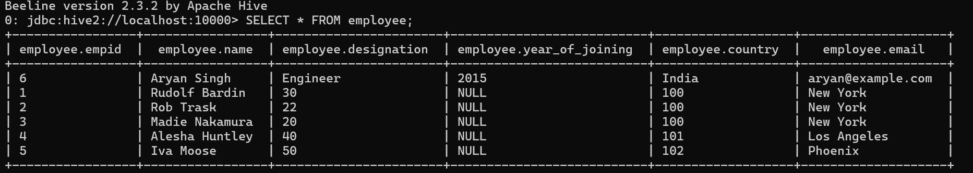

Select where year of joining was 2015
Show partitions:

